Phone
Play
Play
Produce
Appears at
Name
ID
Name
Key
Title
Author
Id
Title
Date
Address
Musician
Instrument
Album
Song
M
M
M
M
1
M
1
M..……

City
St

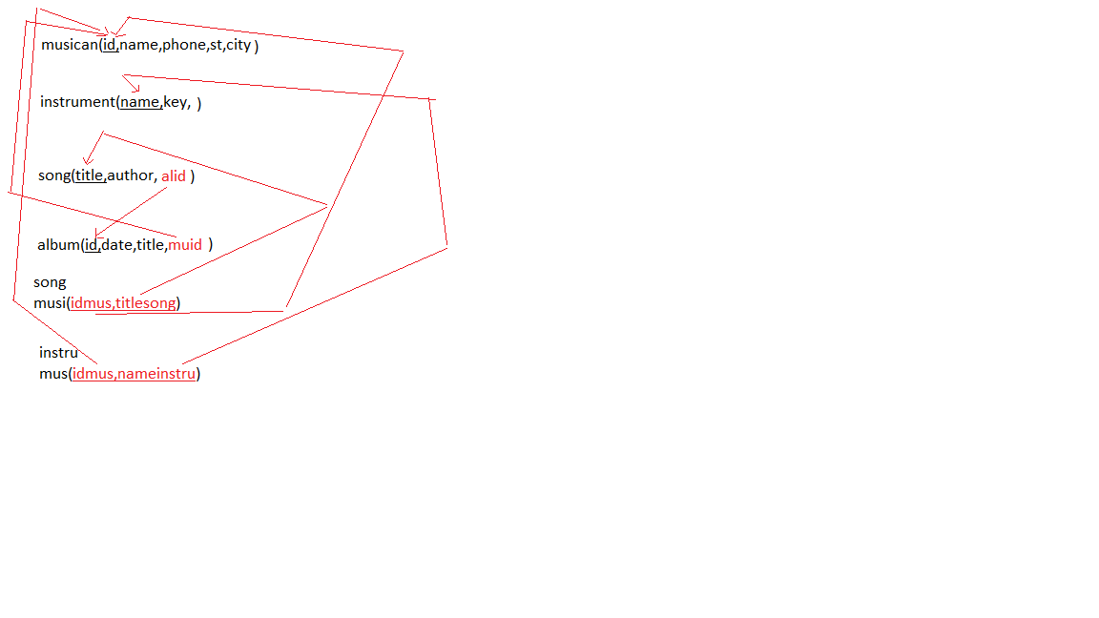

ID
Manage
NUM
Name
1
1

Employee
Sales office
Loc
Work
List
Has
Add
ID
Name
Loc
City
State
Zip
ID
Property
Owner
M
1
M
1
M
M

Percent-owned

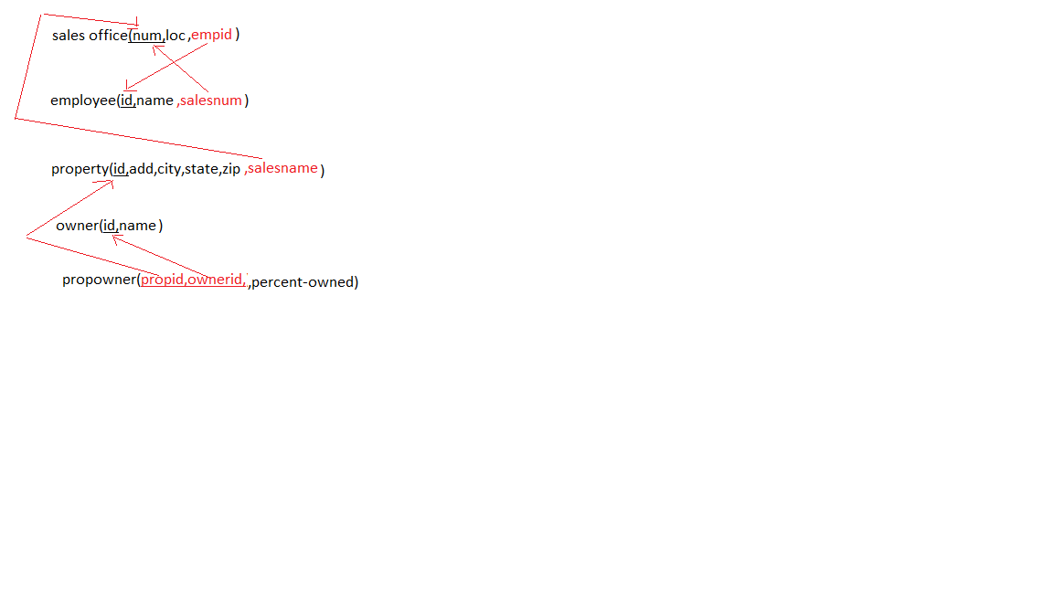

Name
Assigned to
Name
ID
DOB
ID
Dosage
Time
Date
ID
ID
M
1
1
1
1
M
1
M
N
M
M
N
K

Examines
Patient
Consultant

Hosts

Gives
Name

Ward
Drug

Code
Rec Dosage
Brand
Supervises

Serve in
Nurse

Name
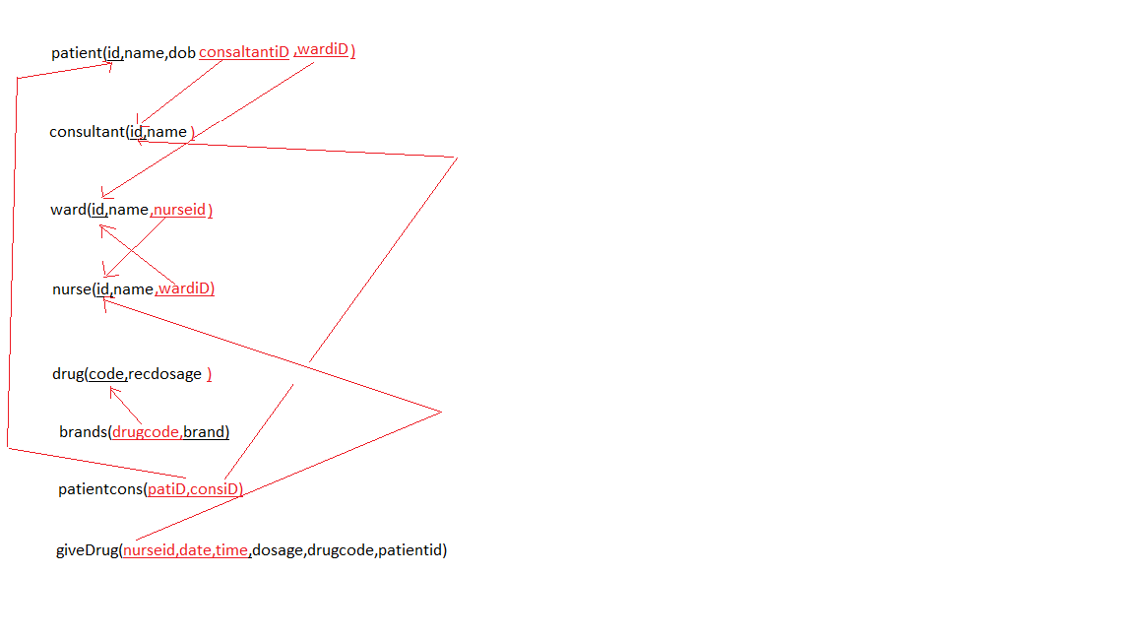
Note: Aircraft can use the same route in different dates

Name
Address
ID
Birthday
Day
Month
Year
Contact Person
Address
Phones
Position
ID
Name

Qualifications

Works in
Airline
Employee
Gender
1
M
Aircraft
ID
Capacity
Model
Transaction
ID
Desc.
Date
Amount
Owns
Assigned
Has
Maj. Pilot
Ass. Pilot
Hostess1
Hostess2
Records
#passe
Time spent
ArrDateTime
Route

ID
Origin
Destination
Classification
Distance
Price/pass
1
M
1
M
1
M
1
M

Crew

Dept DateTime
Crew_ID

